**Exercise ideas for those with physical impairments**

*Handle is optional on all exercises* but may be useful for providing support to adult when assisting in certain exercises.*

*\* (Except for grade 3 exercises where handle should be removed)*

Liaise with physiotherapist before trying any of these exercises

[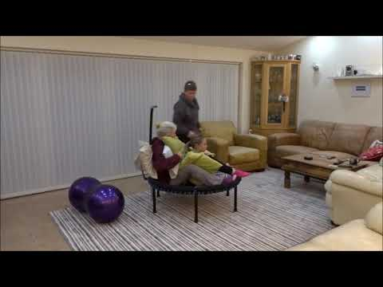](https://www.youtube.com/watch?v=pRH2qt4s5lc)

If the link in the video thumbnail above does not play the video on your device, please use this web page to view:   
<https://www.youtube.com/watch?v=pRH2qt4s5lc>